PRODUCT REQUIREMENTS DOCUMENT

Scout AI - Autonomous Deep Research Engine

A Streaming, Evidence-Grounded Multi-Agent Research Platform

Built on FastAPI, DeepAgents, LangGraph, LangChain, Tavily, OpenAI/Nebius, and LangSmith
Document Information | Current Value
Document Owner | Scout AI Product & Engineering
Version | 1.0
Status | Current-state implementation baseline
Last Updated | 2026-08-30
Classification | Internal product specification
Design Principle | Current, cited evidence through bounded and observable agent workflows

Table of Contents
1. Executive Summary
2. Goals & Success Criteria
3. Target Users, Actors & Personas
4. End-to-End User Journey
5. Functional Requirements
6. Research Brief & Artifact Contracts
7. System Architecture Overview
8. Agent Architecture & LLM Routing
9. Guardrails & Grounding Design
10. State, Persistence & Task Lifecycle
11. Error Handling & Recovery
12. Observability, Streaming & LangSmith
13. UI/UX Requirements
14. Technical Stack Summary
15. Configurable Parameters
16. Non-Functional Requirements
17. Use Cases
18. Phased Release Plan
19. Risks & Mitigations
20. Open Questions
Appendix A - API & Event Contracts
Appendix B - Shared Workspace & Prompt Contracts
Appendix C - Glossary

1. Executive Summary
Scout AI is a browser-based autonomous deep-research application that converts a natural-language question into a sourced research dossier. A DeepAgents supervisor delegates evidence acquisition, analysis, and publication to three bounded sub-agents. Each stage works from an immutable brief and exchanges compact Markdown artifacts through exact virtual paths: /brief.md, /research.md, /analysis.md, and /final.md.
The product supports live research through Tavily plus an OpenAI-compatible model provider, and an explicitly labeled simulation mode that previews workflow structure without claiming verified findings. Live execution is streamed as LangGraph events rather than awaited as one opaque result, allowing the UI to show real milestones, agent activity, retries, backoff, model turns, prompt-token telemetry, and terminal errors.
The implemented application is a single-process FastAPI service with process-local active workers and JSON-backed history. That architecture is appropriate for demonstration and controlled local use, but it does not yet provide durable graph checkpointing, distributed job execution, authentication, encrypted multi-user secret management, or restart-safe task continuation. This PRD distinguishes those current facts from target requirements and roadmap items.
Product Promise: Answer the user's exact question with current, decision-relevant evidence; preserve traceability from recommendation to source; and make multi-agent progress understandable and honest.

2. Goals & Success Criteria

2.1 Product Goals (In Scope)
- Produce a complete executive research dossier from one user query without requiring the user to coordinate individual agents.
- Ground conclusions in authoritative URLs and explicit evidence IDs rather than relying on model memory alone.
- Keep consumer-product research current through runtime dates, a one-year source window, market context, and a latest-available-for-purchase requirement.
- Bound latency, cost, recursion, model turns, retries, search fan-out, and inter-stage context size.
- Expose honest stage milestones and live activity instead of continuously increasing synthetic progress.
- Derive dashboard metrics from the current task's /research.md, /analysis.md, and /final.md artifacts.
- Surface the failing agent's name and actionable reason when a run cannot complete.

2.2 Out of Scope
- Guaranteed truth or completeness for every open-web topic; Scout AI provides evidence-backed research, not certainty.
- Autonomous purchasing, trading, legal filing, medical diagnosis, or other transaction execution.
- Multi-tenant enterprise security, RBAC, SSO, or durable distributed task processing in the current local architecture.
- Full-document retrieval and extraction from every search result; the current research tool passes compact Tavily snippets and metadata.
- Automatic recovery of an in-flight graph after an application restart; current startup reconciliation marks interrupted work failed.

2.3 Success Metrics
Metric | Target | Measurement
Topic fidelity | 100% of completed artifacts repeat and answer the exact original query | Blocking artifact validator
Source traceability | 100% of research evidence records include a URL | research.md schema and URL validation
Hard-path compliance | 100% of agent file operations use approved virtual paths | SharedWorkspacePathMiddleware logs/tests
Terminal-state freshness | UI reflects completed/failed state within 2 seconds | SSE integration test and browser telemetry
Research completion rate | >= 90% for supported benchmark queries | LangSmith evaluation dataset
Latency | P50 < 180s; P95 < 360s for comprehensive live research | Task duration telemetry
Citation usefulness | >= 85% of sampled citations support the associated claim | Human/LLM-judge audit
Constraint compliance | 100% adherence to configured turn, recursion, concurrency, and artifact budgets | Runtime middleware + regression tests

3. Target Users, Actors & Personas
Actor / Persona | Primary Need | Scout AI Value | Key Concern
Executive decision-maker | A concise decision brief with risks and actions | Executive synthesis, comparative matrices, citations | Confidence and source quality
Strategy or market analyst | Rapid evidence collection and structured comparisons | Evidence ledger, analysis matrix, downloadable artifacts | Coverage gaps and reproducibility
Consumer / procurement researcher | Current product recommendations and ownership trade-offs | Runtime date, one-year search window, latest-purchase requirement | Model-year and availability accuracy
Product manager | Competitive, customer, and technology research | Reusable query starters, radar/SWOT, artifact history | Metrics must reflect the current query
Research lead / reviewer | Inspectable provenance and assumptions | research.md, analysis.md, final.md, LangSmith traces | Hallucination and unsupported synthesis
Application operator | Configure providers and diagnose failures | Settings UI, agent names in errors, live telemetry | Timeouts, quota, TLS, restart safety
API integrator | Programmatic task initiation and event consumption | REST start/history/export endpoints and SSE stream | Stable contracts and authentication

3.1 Stakeholders
- Product owner: defines supported research experiences, reliability bar, and launch scope.
- AI/agent engineer: owns prompts, graph behavior, middleware, provider/model routing, and evaluations.
- Backend engineer: owns FastAPI contracts, persistence, task lifecycle, export, and operational safety.
- Frontend engineer/designer: owns research intake, live topology, progress, dossier visualization, and accessibility.
- Security/operations reviewer: owns key handling, network trust, auditability, deployment, and incident response.

4. End-to-End User Journey
- Open Scout AI and begin from a clean dashboard with no stale query, progress, results, or metrics.
- Enter a specific research question; choose depth (quick, comprehensive, exhaustive), focus, final synthesis model, and live or simulation mode.
- Submit the query. The API validates non-empty input and required provider keys, creates a task, and returns a task ID.
- Scout AI constructs /brief.md with the exact question, depth/focus, runtime date, one-year source-window start, United States market, and latest-purchasable-product requirement.
- The Orchestrator reads the brief and delegates Research, Analysis, and Writer work using full task descriptions and exact shared paths.
- The UI receives SSE events every approximately 600 ms and shows milestone progress, the active green topology path, logs, model turns, attempts, prompt tokens, and last activity only when available.
- On success, Scout AI validates artifacts, derives current-task metrics, persists history, renders the Markdown dossier and charts, and enables DOCX export.
- On failure, Scout AI stops at 100%, identifies the responsible agent where known, records the actionable error, and leaves the task in history.
- The user can inspect research, analysis, final report, workspace files, citations, and historical dossiers or start a clean new task.
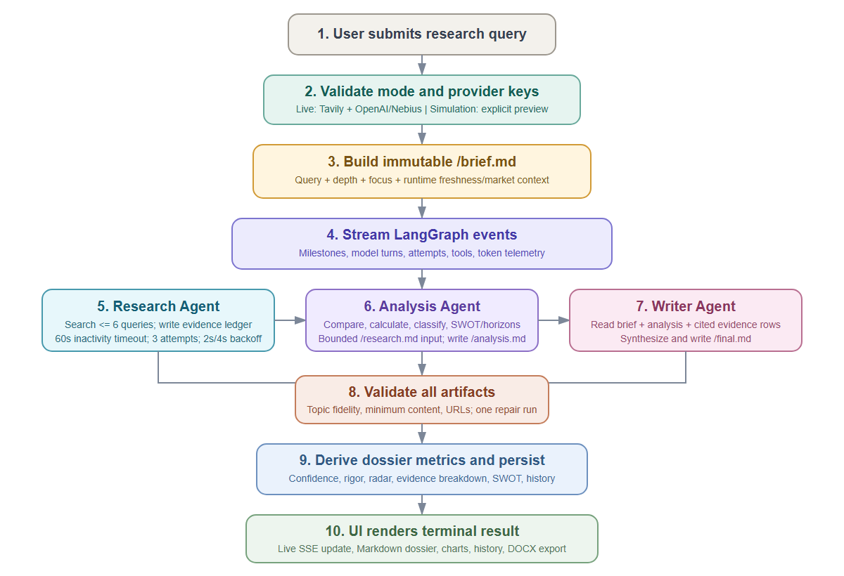
Figure 1. Scout AI end-to-end live research and artifact flow.

5. Functional Requirements
ID | Capability | Requirement / Acceptance
FR-001 | Query intake | Accept a non-empty natural-language research query; reject blank input with HTTP 422.
FR-002 | Research controls | Support quick/comprehensive/exhaustive depth, general/news/finance/academic focus, model selection, and explicit simulation mode.
FR-003 | Clean start | On page refresh, clear the active query, progress, results, activity labels, and derived metrics.
FR-004 | Live prerequisites | Require Tavily plus either OpenAI or Nebius credentials for live mode; return HTTP 503 when unavailable.
FR-005 | Immutable brief | Create /brief.md for every run and make it the authoritative context for all agents.
FR-006 | Runtime freshness | Write AS_OF_DATE, SOURCE_WINDOW_START, MARKET, and PRODUCT_REQUIREMENT into /brief.md.
FR-007 | Exact delegation context | Every task delegation includes the complete original query, stage objective, inputs, output path, and acceptance check.
FR-008 | Research stage | Search authoritative web sources in bounded parallel batches and write a compact evidence ledger with URLs to /research.md.
FR-009 | Analysis stage | Read bounded evidence, classify facts/inferences/assumptions, compare options, calculate metrics, and write /analysis.md.
FR-010 | Writer stage | Use /brief.md, /analysis.md, and cited evidence excerpts to create a publication-grade /final.md.
FR-011 | Artifact validation | Block completion when artifacts are missing, too short, off-topic, placeholder-based, or lack research URLs; permit one repair workflow.
FR-012 | Event streaming | Use LangGraph astream_events(version='v2') and SSE; do not await one opaque agent result.
FR-013 | Honest progress | Use milestones (Research 35-55%, Analysis 60-75%, Writer 80-92%, completion 100%) with activity telemetry.
FR-014 | Retries | Apply one initial attempt plus two retries to Research, Analysis, and Writer agents after 60 seconds of inactivity.
FR-015 | Backoff | Wait 2 seconds after the first timeout and 4 seconds after the second before retrying.
FR-016 | Bounded execution | Enforce agent model-call limits, graph recursion limit, and maximum concurrency.
FR-017 | Context budgets | Cap intermediate artifacts, line reads, result counts, and snippets to prevent context growth.
FR-018 | Failure attribution | Include the failing agent name for timeout, iteration, and graph-stop failures when identifiable.
FR-019 | Artifact-derived analytics | Populate SWOT/horizon, evidence rigor, radar, logic rigor, read time, and strategic confidence from the current artifacts.
FR-020 | History | List, load, recompute metrics for, and delete stored dossiers.
FR-021 | Export | Export final report and optional research/analysis appendices as a DOCX download.
FR-022 | Settings | Configure API keys, router/synthesis models, base URL, LangSmith key, and LangSmith project through the UI/API.
FR-023 | TLS trust | Use the Windows trust store for Tavily, LangSmith, and OpenAI-compatible HTTPS connections.
FR-024 | Simulation labeling | Never represent simulation output as verified evidence; label all preview artifacts and metrics accordingly.

6. Research Brief & Artifact Contracts

6.1 Immutable Research Brief
The brief prevents context loss across isolated sub-agent sessions. It is generated once per task, injected into the DeepAgents virtual filesystem, and read before every stage.
ORIGINAL USER QUESTION: <verbatim query>
RESEARCH DEPTH: <quick|comprehensive|exhaustive>
RESEARCH FOCUS: <general|news|finance|academic>
AS_OF_DATE: YYYY-MM-DD
SOURCE_WINDOW_START: YYYY-MM-DD (AS_OF_DATE - 365 days)
MARKET: United States
PRODUCT_REQUIREMENT: Latest model/version currently available for purchase

6.2 Shared Artifact Contracts
Path | Owner | Purpose | Implemented Budget
/brief.md | Application / Orchestrator | Immutable query and runtime context | Read <= 60 lines
/research.md | Research Agent | Evidence Ledger: <= 30 records plus <= 5 gaps | <= 100 lines and <= 16,000 chars
/analysis.md | Analysis Agent | Decision summary, finding matrix, comparison, risks, actions, SWOT/horizons | <= 80 lines and <= 12,000 chars
/final.md | Writer Agent | Publication-grade answer and citations | Orchestrator final read <= 120 lines

Context quarantine: Sub-agents do not inherit the prior user conversation. /brief.md plus the full task description are the only authoritative bridges for the original topic.

7. System Architecture Overview
Scout AI is a layered local web application. The browser submits and visualizes work; FastAPI manages task state and streaming; the DeepAgents supervisor executes a LangGraph-backed agent graph; specialized agents use a virtual shared workspace; external model/search providers supply inference and current web evidence; LangSmith receives nested traces; and a JSON file stores dossier history.
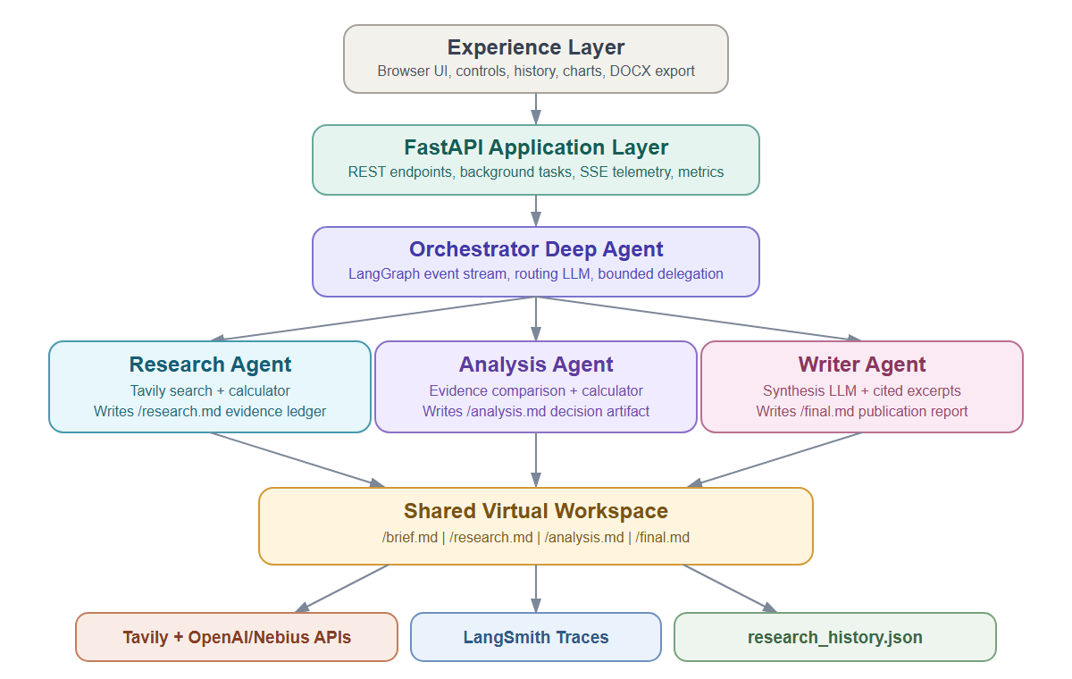
Figure 2. Implemented Scout AI component and data architecture.

7.1 Runtime Boundaries
- Browser boundary: static HTML/JavaScript, Tailwind styling, event-stream consumer, charts, Markdown/KaTeX rendering, settings, history, and export actions.
- Application boundary: one Uvicorn/FastAPI process, in-memory TASKS dictionary, FastAPI BackgroundTasks, JSON persistence, and direct provider network calls.
- Agent boundary: a DeepAgents supervisor compiled over LangGraph; sub-agents have isolated prompts/tools and share virtual FileData objects.
- Provider boundary: Tavily search and OpenAI-compatible chat completions through OpenAI or Nebius endpoints.
- Observability boundary: standard LangSmith environment variables automatically capture nested model, tool, and sub-agent runs.

7.2 Current Persistence Model
Completed and failed dossier records are saved to research_history.json (latest 50 tasks). Active work is not checkpointed outside the process. On application startup, any persisted task still marked in_progress is reconciled to failed with an explicit restart-interruption error.

8. Agent Architecture & LLM Routing

8.1 Agent Roster
Agent | Responsibility | Tools | Output | Turn Limit
Orchestrator | Plan, delegate, review bounded artifacts, validate, repair once, terminate | internet_search, calculator, DeepAgents task/file tools | Final graph state | 12
Research Agent | Acquire current authoritative evidence and source metadata | internet_search, calculator, read_file, write_file | /research.md | 10
Analysis Agent | Compare evidence, calculate, classify, identify risks/actions/SWOT | calculator, read_file, write_file | /analysis.md | 7
Writer Agent | Synthesize decision-ready report from brief, analysis, and cited rows | read_file, grep, write_file | /final.md | 10

8.2 LLM Role Routing
Scout AI resolves two logical model roles. The router model is used by the Orchestrator, Research Agent, and Analysis Agent for planning, tool selection, and structured reasoning. The synthesis model is reserved for the Writer Agent. When both roles resolve to the same model, one model client is reused.
Model / Family | Provider Path | Role / Availability | Notes
Qwen/Qwen3-30B-A3B-Instruct-2507 | Nebius OpenAI-compatible API | Default Nebius router and synthesis; settings option | Current local baseline; selected when OpenAI key is absent
Qwen/Qwen3-235B-A22B-Instruct-2507 | Nebius OpenAI-compatible API | Optional final synthesis | Higher-quality/larger writer choice exposed in settings
gpt-4o-mini | OpenAI API | Default OpenAI router and synthesis | Fast/cost-efficient default when OpenAI is configured
gpt-4o | OpenAI API | Optional final synthesis | Settings option for higher-precision general synthesis
o3-mini | OpenAI API | Optional final synthesis | Settings option oriented to reasoning/STEM
o1 | OpenAI API | Optional final synthesis | Settings option for deeper reasoning
claude-3-7-sonnet | Catalog entry only | Returned by /api/config catalog; not in settings selector | No native Anthropic client is implemented; requires a compatible endpoint before production use

Model configuration: All model clients use temperature 0.1, a 60-second provider request timeout, and two provider-level retries. Agent-level inactivity retries are a separate middleware layer.

8.3 Delegation Contract
ORIGINAL USER QUESTION: <verbatim question from /brief.md>
STAGE OBJECTIVE: <specific bounded work>
REQUIRED INPUTS: </brief.md and approved prior-stage paths>
REQUIRED OUTPUT: </research.md | /analysis.md | /final.md>
ACCEPTANCE CHECK: Output directly addresses the original question

9. Guardrails & Grounding Design
Control | Implementation | Risk Addressed
Exact-query repetition | Every stage must begin with the exact original question | Topic drift across isolated contexts
Research URL requirement | research.md must contain at least one HTTP(S) source URL | Untraceable model-only research
Evidence ledger | Compact rows with ID, claim/metric, date/scope, URL, type, confidence | Verbose unstructured handoffs
Fact/inference/assumption split | Analysis finding matrix labels epistemic status and evidence IDs | Inference presented as fact
Relevant excerpt retrieval | Writer greps cited evidence IDs; bounded fallback only when IDs are absent | Context inflation and unrelated evidence
Freshness context | Runtime date, one-year window, U.S. market, latest-purchase requirement | Stale consumer-product recommendations
Tavily time range | internet_search sets time_range='year' | Older result ranking
Artifact caps | Hard line/character budgets with cap notice | Runaway prompts and provider latency
Tool safety | Calculator accepts only digits and standard arithmetic characters | Arbitrary code execution
Path enforcement | Fixed workspace files and bounded read/write middleware | Uncontrolled filesystem exploration
Final validation | Minimum length, exact query, URL, and placeholder checks; one repair attempt | False success with incomplete artifacts

9.1 Known Grounding Limits
- A one-year search filter constrains result recency but does not prove that a product model is currently purchasable or that a cited model year is the newest available.
- The Tavily tool returns title, URL, compact snippet, published date, and score; it does not fetch and archive full source documents.
- Search snippets can omit qualifiers, paywalled details, methodology, or regional availability; key decisions still require primary-source verification.
- Strategic confidence is a deterministic artifact-quality score, not a calibrated probability that every conclusion is correct.

10. State, Persistence & Task Lifecycle
State Area | Current Storage | Lifecycle / Semantics
Active task object | Process-local TASKS dictionary | Created at POST /start; mutated by BackgroundTasks; lost if process exits
Agent graph state | In-memory LangGraph execution | Streamed through astream_events; no durable checkpointer configured
Shared artifacts | DeepAgents virtual FileData during execution; copied into task record on completion | brief/research/analysis/final exact paths
History | research_history.json | Latest 50 records; saved repeatedly; reloaded on startup
Interrupted work | Startup reconciliation | Persisted in_progress task becomes failed with restart-interruption message
Provider settings | .env plus process environment | Updated through settings API; keys are not returned to the browser
Trace history | LangSmith project when configured | Nested agent/model/tool runs and metadata

10.1 Task Status Model
in_progress -> completed
in_progress -> failed
in_progress --application restart--> failed (startup reconciliation)
completed/failed -> history load or delete
There is no current paused, cancelled, queued, or resumable status.

10.2 Target Durability Requirement
A production release should move execution into durable workers backed by a database and LangGraph checkpointer. The task ID must remain stable across process restarts; every stage write and terminal transition must be idempotent; active work must either resume from the last checkpoint or fail with a durable, visible reason.

11. Error Handling & Recovery
Failure | Detection | Current Recovery / Surface
Missing query | Input validation | HTTP 422 with specific message
Missing live credentials | Start endpoint provider check | HTTP 503; user may explicitly choose simulation
TLS certificate chain | HTTPS client exception | truststore injects Windows certificate store; verification remains enabled
Tavily transient failure | Search exception | Up to 3 total attempts with 2s/4s waits
Sub-agent inactivity | No model/tool/token/chain callback for 60s | Cancel attempt; retry twice with 2s/4s backoff; name failing agent
Model-call limit | ModelCallLimitMiddleware | Raise agent-specific iteration-limit error
Graph stop failure | LangGraph GraphRecursionError | Surface active agent plus configured 50-step graph budget
Provider quota/credits | 429/quota/credit error text | Actionable billing/provider error
Artifact validation | Blocking post-run validator | One bounded repair graph; then fail explicitly
Application restart | Startup sees persisted in_progress task | Mark failed; current execution cannot resume
SSE disconnect | Browser EventSource.onerror | Current UI closes stream and re-enables start; target behavior is reconnect/fetch terminal state

Reliability distinction: The 60-second policy measures inactivity, not total stage duration. Healthy model tokens, tool calls, and chain events reset the clock so productive long-running work can continue.

12. Observability, Streaming & LangSmith

12.1 Event Streaming
The graph is executed with agent.astream_events(..., version='v2'). Nested task ancestry attributes model and tool events to the correct sub-agent. The backend converts events into StreamTelemetry and publishes current task state through an SSE endpoint roughly every 600 ms.
Telemetry | Examples | UI / Operational Use
Milestone | 30 orchestrator; 35/55 research; 60/75 analysis; 80/92 writer; 100 terminal | Honest progress bar
Agent activity | active_agent, current_tool, last_activity_epoch | Green topology path and slow-provider warning
Model usage | turn number/limit; prompt/completion/total tokens when available | Cost/context diagnostics
Retry state | attempt, max_attempts, timeout, backoff, activity_state | Visible retry countdown and failure context
Delegation | per-agent invocation counts | Detect rework and repeated stages
Artifacts | current file lengths; full files at terminal state | Verify stage output and render result
Quality | source count, confidence, metrics | Dossier analytics

12.2 LangSmith Tracing
- LANGSMITH_API_KEY enables tracing; LANGSMITH_TRACING defaults true when the key is present.
- LANGSMITH_PROJECT defaults to scout-ai and is configurable in settings.
- Standard LangChain/DeepAgents integration emits nested model, tool, chain, and sub-agent runs.
- Trace config includes task ID, depth, focus, selected model, execution mode, recursion limit, and tags.
- Recommended evaluations: groundedness, citation support, topic fidelity, route accuracy, artifact contract, latency, token usage, and completion rate.

12.3 Artifact-Derived Dashboard Metrics
SWOT and horizons are extracted from /analysis.md; evidence rigor from /research.md; comparative radar from structured analysis; read time from /final.md; and strategic confidence from current-task evidence coverage, source quality, analysis grounding, gap disclosure, freshness, and final traceability. The UI must not substitute placeholder values when artifacts are absent.

13. UI/UX Requirements
Area | Requirement
Research intake | Prominent query field, depth controls, focus dropdown defaulting to All Authoritative Web, explicit simulation toggle, and start action.
Clean refresh | Clear query, progress, results, activity telemetry, charts, confidence, and selected dossier; preserve only configuration/history.
Live topology | Distinct high-contrast node colors; active path green; readable labels above nodes; clear spacing to Shared Workspace.
Progress | Milestone percentage plus active agent; no synthetic continuous movement.
Optional activity | Hide Model call, Attempt, Prompt tokens, and Last activity fields when their values are absent or waiting.
Latency warning | After 45 seconds without model activity, state that provider response is slow and show estimated timeout remaining.
Backoff | Show agent attempt timed out and exact retry wait (2 or 4 seconds).
Results | Tabs for analytics, final.md, research.md, analysis.md, and shared files.
Analytics | Render current-query strategic confidence, evidence rigor chart, comparative radar, SWOT, and decision horizons.
Accessibility | High contrast, semantic labels, keyboard focus, responsive layout, readable chart legends, and non-color-only status cues.
History | Searchable drawer; status, query, duration, sources, confidence; load and delete actions.
Failure | Stop activity indicator, restore start button, show terminal error and failed agent, and retain the failed task in history.

13.1 Visual System
The interface uses a dark slate background with teal/cyan/indigo accents, high-contrast glass panels, Inter and JetBrains Mono typography, and distinct colors for Orchestrator, Research, Analysis, Writer, and Shared Workspace nodes. Chart palettes must use multiple distinguishable colors and textual legends.

14. Technical Stack Summary
Concern | Implemented Technology | Version / Notes
Language/runtime | Python | Local virtual environment based on Python 3.14
Web API | FastAPI | 0.141.1
ASGI server | Uvicorn | 0.52.4
Agent framework | DeepAgents | 0.7.11
Agent/tool primitives | LangChain + langchain-openai | 1.3.18 / 1.6.0
Graph runtime | LangGraph | 1.2.11; event streaming v2
Tracing/evals | LangSmith | 0.11.2
Web research | Tavily Python SDK | 0.8.0
Configuration | python-dotenv | 1.2.3; .env and process environment
Document export | python-docx | 1.2.0
TLS trust | truststore | 0.10.4; Windows trust store injection
Frontend | HTML5 + vanilla JavaScript | Server-rendered static template; no build step
Styling | Tailwind CSS CDN + custom CSS | CDN dependency currently unpinned
Visualization | Chart.js | CDN; radar and evidence-rigor charts
Markdown/math | marked.js + KaTeX | CDN-based rendering
Icons/animation | Font Awesome + canvas-confetti | CDN-based UI enhancement
Persistence | JSON file + process memory | research_history.json; latest 50 tasks

15. Configurable Parameters

15.1 Runtime Reliability and Context Parameters
Parameter | Current Value | Purpose
AGENT_TIMEOUT_SECONDS | 60 | Inactivity timeout for delegated agents and provider request timeout
AGENT_MAX_RETRIES | 2 | Two retries after the initial attempt; three attempts total
Retry backoff | 2s, then 4s | Computed as 2^attempt_number; not separately configurable
RESEARCH_AGENT_MAX_TURNS | 10 | Research model-call run limit
ANALYSIS_AGENT_MAX_TURNS | 7 | Analysis model-call run limit
WRITER_AGENT_MAX_TURNS | 10 | Writer model-call run limit
ORCHESTRATOR_MAX_TURNS | 12 | Supervisor model-call run limit
AGENT_MAX_CONCURRENCY | 5 | LangGraph maximum concurrent work
GRAPH_RECURSION_LIMIT | 50 | Graph node-transition budget passed at invocation
RESEARCH_ARTIFACT_MAX_LINES | 100 | Maximum research.md lines
RESEARCH_ARTIFACT_MAX_CHARS | 16,000 | Hard research.md character cap
ANALYSIS_ARTIFACT_MAX_LINES | 80 | Maximum analysis.md lines
ANALYSIS_ARTIFACT_MAX_CHARS | 12,000 | Hard analysis.md character cap
BRIEF_READ_MAX_LINES | 60 | Maximum brief read
FINAL_READ_MAX_LINES | 120 | Maximum orchestrator final verification read
WRITER_RESEARCH_FALLBACK_MAX_LINES | 40 | Fallback evidence read when analysis IDs are missing
SEARCH_MAX_RESULTS_PER_QUERY | 3 | Maximum Tavily results returned per query
SEARCH_RESULT_SNIPPET_CHARS | 600 | Maximum snippet characters per result
Research search count | <= 6 | Prompt-level total query cap in at most two parallel batches
Tavily time_range | year | One-year search-result constraint
Model temperature | 0.1 | Low-variance model configuration
SSE interval | ~0.6 seconds | Backend event-generator update cadence
Slow-provider warning | 45 seconds | Frontend warning threshold before 60-second inactivity timeout
History retention | 50 tasks | Latest records persisted to JSON

15.2 Environment and Provider Parameters
Environment Variable | Default / Behavior | Used By
OPENAI_API_KEY | Optional; takes precedence over Nebius when present | OpenAI model access
OPENAI_MODEL | gpt-4o-mini | OpenAI synthesis model
OPENAI_ROUTER_MODEL | gpt-4o-mini | OpenAI router/research/analysis
OPENAI_BASE_URL | Empty (official endpoint) | Optional OpenAI-compatible base URL
NEBIUS_API_KEY | Optional alternative model provider | Nebius model access
NEBIUS_MODEL | Qwen/Qwen3-30B-A3B-Instruct-2507 | Nebius synthesis model
NEBIUS_ROUTER_MODEL | Qwen/Qwen3-30B-A3B-Instruct-2507 | Nebius router/research/analysis
NEBIUS_BASE_URL | https://api.studio.nebius.ai/v1/ | OpenAI-compatible Nebius endpoint
SCOUT_ROUTER_MODEL | Unset | Provider-independent router override
TAVILY_API_KEY | Required for live mode | Web research
LANGSMITH_API_KEY | Optional | Nested tracing
LANGSMITH_PROJECT | scout-ai | Trace project routing
LANGSMITH_TRACING | true when LangSmith key exists | Tracing enablement

15.3 User-Selectable Parameters
Control | Values | Effect
Depth | quick | comprehensive | exhaustive | Prompt/tag metadata; future policy may vary search and synthesis budgets
Focus | general | finance | news | academic | Brief and trace context; web tool natively supports general/news/finance
Final model | Configured OpenAI/Nebius selections | Writer synthesis model
Routing model | Fast provider-specific model | Orchestrator, Research, and Analysis model
Simulation | off by default; explicit toggle | Unverified workflow preview with no live provider requirement

16. Non-Functional Requirements
Category | Target Requirement | Current Baseline / Gap
Availability | 99.5% monthly for production service | Local single process; no HA
Durability | No terminal task loss on deploy/restart | In-flight work fails on restart; no checkpoint
Performance | P50 < 180s; P95 < 360s comprehensive | Provider-dependent; telemetry available
Streaming | Terminal UI state <= 2s after backend transition | SSE works while connected; disconnect reconciliation gap
Scalability | Independent API/workers; queue-based horizontal scaling | BackgroundTasks in web process
Security | Auth, RBAC, encrypted secrets, CSRF controls, audit log | No auth; .env key updates; local-use assumption
Privacy | No secrets or sensitive queries in client logs/traces without policy | Keys not returned; query/trace retention requires governance
Accessibility | WCAG 2.1 AA for primary workflow | High contrast improvements; formal audit pending
Auditability | Every decision traceable to evidence IDs and trace run | Artifact IDs and optional LangSmith supported
Testability | Unit, contract, integration, browser, and evaluation gates | Python unit tests exist; browser/eval suite should expand
Compatibility | Current Chrome/Edge/Firefox; responsive desktop/mobile | CDN-based modern browser UI
Maintainability | Version-pinned dependencies and documented config | Python versions identified; frontend CDN versions partly unpinned

17. Use Cases
Use Case | Example Query / Actor | Expected Outputs
Consumer product recommendation | Buyer: 'Find the top three current cars for reliability, fuel economy, resale value, and TCO.' | Current-market evidence ledger; candidate comparison; recommendation; freshness caveats; cited final report
Enterprise vendor strategy | Executive: 'Compare Microsoft, Google, and Amazon enterprise generative-AI strategies.' | Competitive evidence, SWOT/horizons, strategic radar, decision actions
Technology architecture selection | CTO: 'Compare DeepAgents, LangGraph, CrewAI, and AutoGen for production.' | Feature/operating trade-offs, risks, fit-by-use-case, recommendation
Emerging technology timeline | Investor/analyst: 'Assess solid-state battery commercialization from 2026-2030.' | Dated milestones, company evidence, uncertainty ranges, horizon matrix
Supply-chain resilience | Operations leader: 'Evaluate 2nm GAA yields, packaging capacity, and geopolitical exposure.' | Evidence matrix, bottlenecks, scenarios, mitigations
Market intelligence | Product manager: 'Research current competitors, pricing, and customer signals.' | Structured source dossier, comparison, gaps, launch implications
Policy/standards landscape | Compliance analyst: 'Summarize current requirements and implications.' | Primary-source emphasis, effective dates, uncertainty, and verification notes
Workflow preview | Operator without live keys enables Simulation | Clearly labeled research/analysis/report plan with zero verified claims
Post-run audit | Reviewer opens history and artifact tabs | Exact brief, evidence IDs/URLs, analysis lineage, report, trace metadata

17.1 Use-Case Acceptance Pattern
- The final report states the exact original question and directly answers it.
- Recommendations link to evidence records and disclose missing or stale data.
- Consumer-product answers explicitly distinguish current availability from historical model-year evidence.
- Unsupported metrics, SWOT items, radar values, or confidence values remain absent rather than populated with placeholders.
- Failures terminate visibly and name the responsible agent when known.

18. Phased Release Plan
Phase | Scope | Exit Criteria
Phase 0 - Current baseline | Local FastAPI application; multi-agent artifacts; event streaming; retries; artifact metrics; history/export; LangSmith | Existing regression suite passes; documented local operation
Phase 1 - Reliability | SSE reconnect/final fetch; task cancellation; graceful deploy drain; durable checkpoint; resumable task; per-stage deadlines | No stale progress after disconnect; restart test resumes or cleanly terminates every task
Phase 2 - Evidence quality | Primary-source policy; date/availability validator; duplicate-source controls; full-text extraction; source snapshots; calibrated eval datasets | Citation-support and freshness thresholds pass benchmark suite
Phase 3 - Production platform | Database, queue workers, auth/RBAC, encrypted secret store, tenant isolation, rate limits, retention policy | Security review and load/SLO tests pass
Phase 4 - Enterprise optimization | Model routing experiments, caching, provider failover, cost budgets, admin/eval dashboards, API versioning | Cost/latency targets met without groundedness regression

19. Risks & Mitigations
Risk | Impact | Mitigation / Requirement
Application restart during live research | Task appears stalled or fails; work lost | Durable checkpointer and worker queue; graceful drain; UI terminal-state refetch
Provider latency after large search batches | 60s inactivity retries, repeated cost, no artifact | Earlier synthesis/write, smaller batches, streaming providers, stage-specific timeout, cache search results across retries
Repeated retries duplicate searches | Token/cost growth and rate-limit pressure | Persist evidence batch and resume synthesis; idempotency keys; retry only failed step
SSE disconnect leaves stale progress | User sees 35% after backend failure | Reconnect with exponential backoff; GET current task on error; render terminal state
JSON persistence under multiple workers | Lost updates or corruption | Transactional database with optimistic locking
Search recency mistaken for product currency | Old model-year recommendation | Validate official availability, on-sale status, publication date, and replacement generation
Snippet-only evidence | Claim misses caveat or methodology | Fetch primary page content; archive excerpt and retrieval timestamp
Prompt/model changes cause loop behavior | Iteration or recursion failures | LangSmith regression evaluations and versioned prompts/models
Settings endpoint stores secrets without auth | Credential compromise | Authentication, secret vault, CSRF protection, no plaintext .env writes in production
Unpinned CDN dependencies | Supply-chain or visual regressions | Pin versions, integrity hashes, or bundle reviewed frontend assets
Confidence score overinterpreted | False certainty | Label as artifact-quality score; expose components and gaps; calibrate against evaluations
No cancellation or queue status | Resource waste and confusing UX | Add queued/running/cancelling/cancelled states and cancellation propagation

20. Open Questions
- Which user segments and research domains define the launch benchmark dataset?
- Should research depth change agent/search/token budgets, or remain descriptive metadata?
- Which source domains and source types qualify as authoritative for each focus category?
- What evidence freshness rule applies when no source exists inside the one-year window?
- Should the latest-purchasable-product constraint vary by market instead of defaulting to the United States?
- Which durable execution architecture is preferred: LangGraph checkpointer in the API process, a separate worker queue, or both?
- What maximum total task cost, token budget, and wall-clock deadline should be enforced?
- Which models/providers are approved for production, and what failover order applies?
- What data retention and PII-redaction rules apply to queries, artifacts, JSON/database records, and LangSmith traces?
- Should users edit and resume intermediate artifacts, or should the pipeline remain fully autonomous?
- How should the strategic confidence score be calibrated and presented to avoid probability-like interpretation?
- What authentication, tenant isolation, and audit requirements apply before remote deployment?

21. User Interface
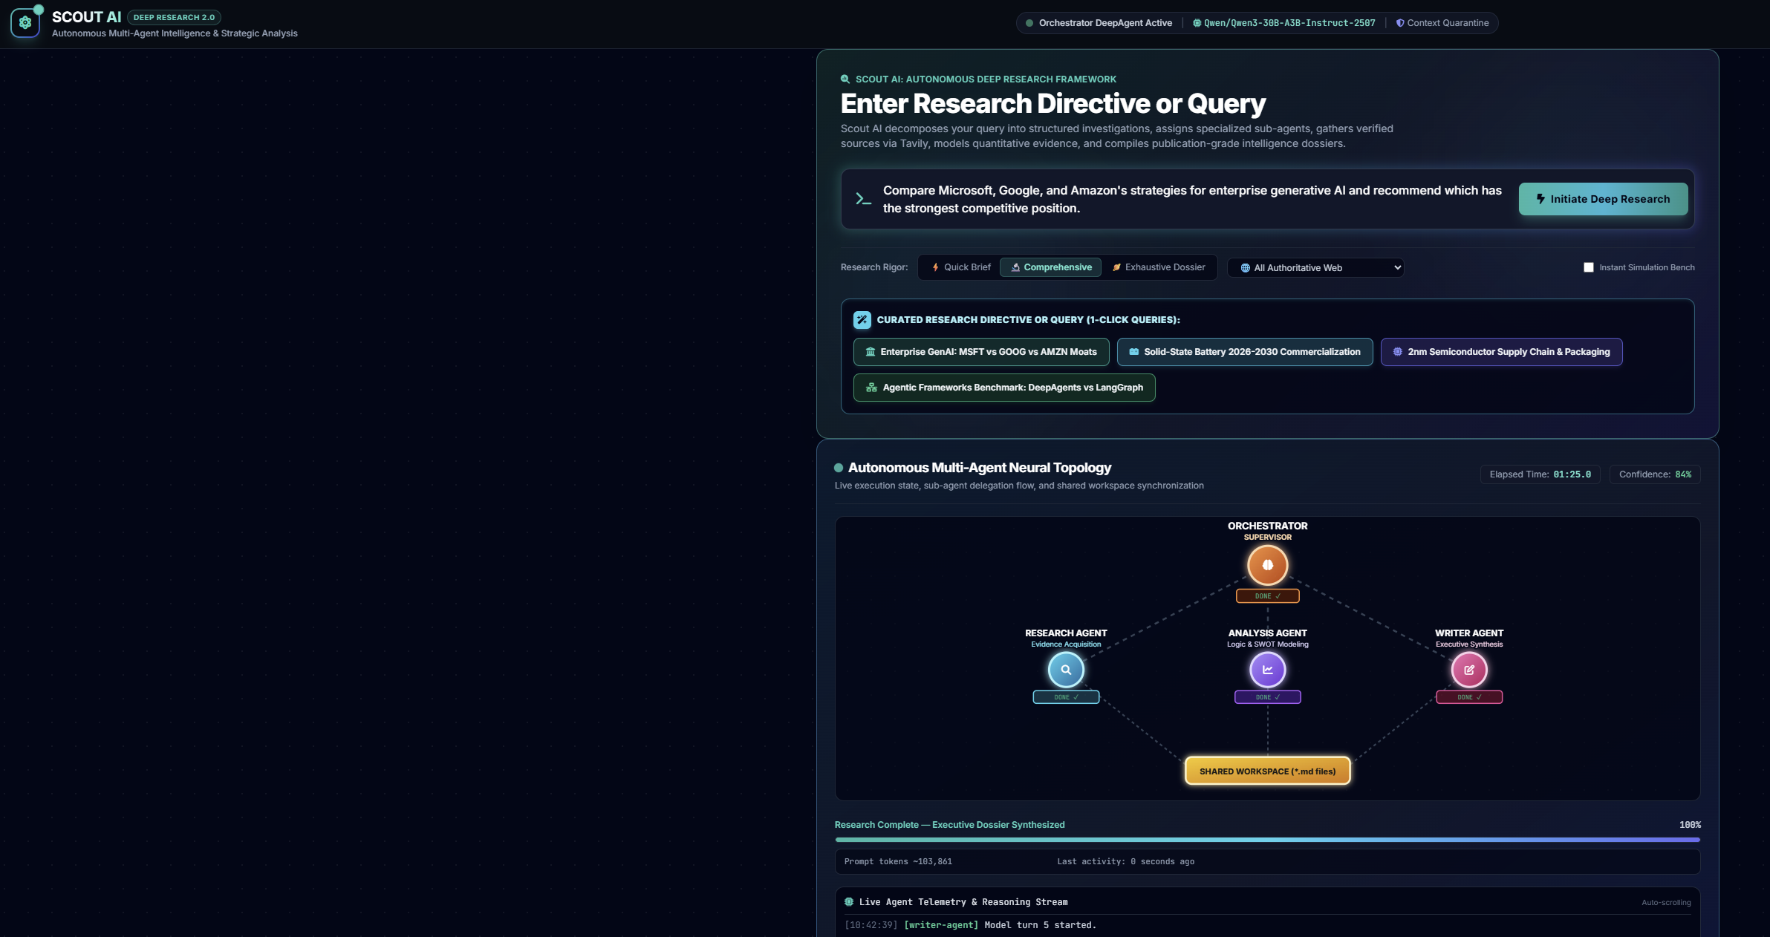

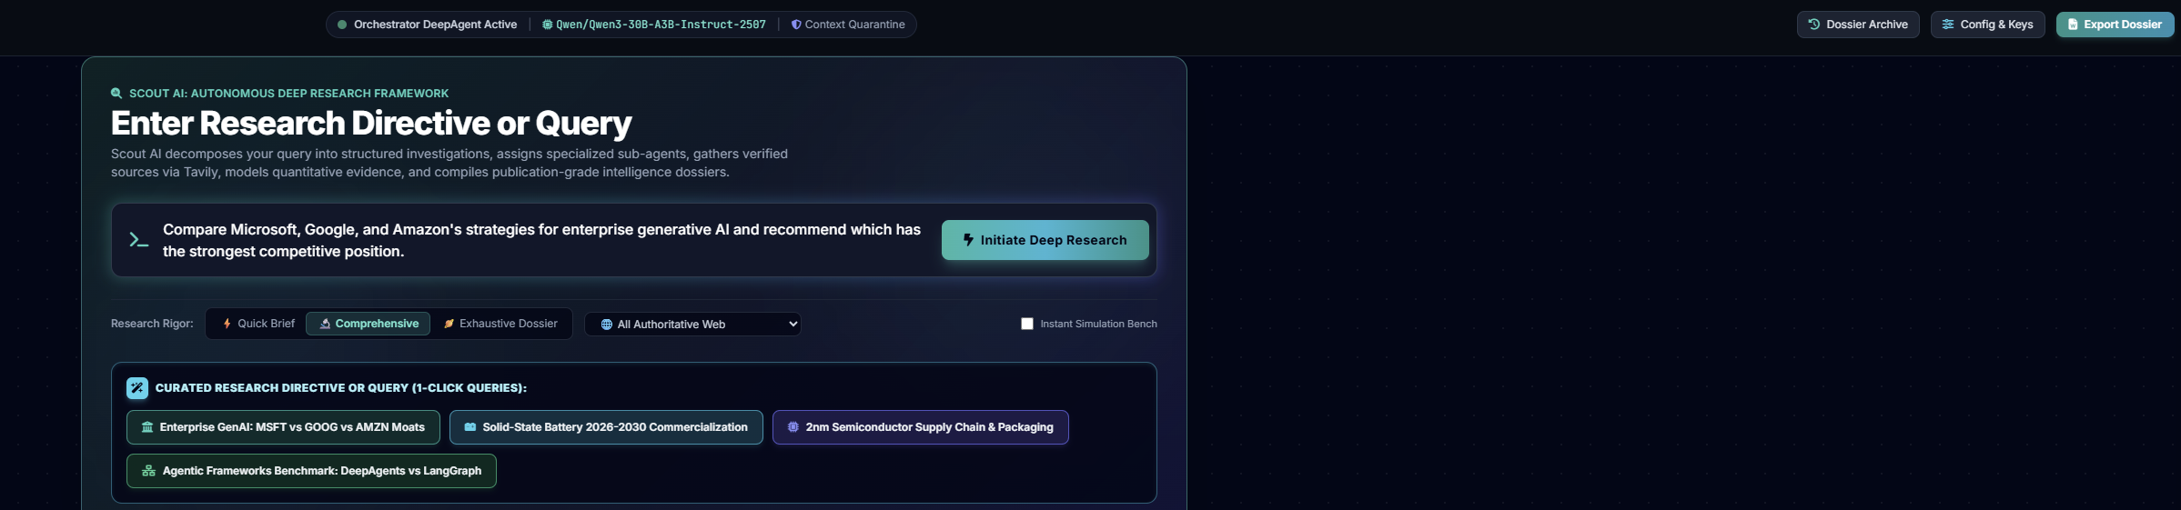

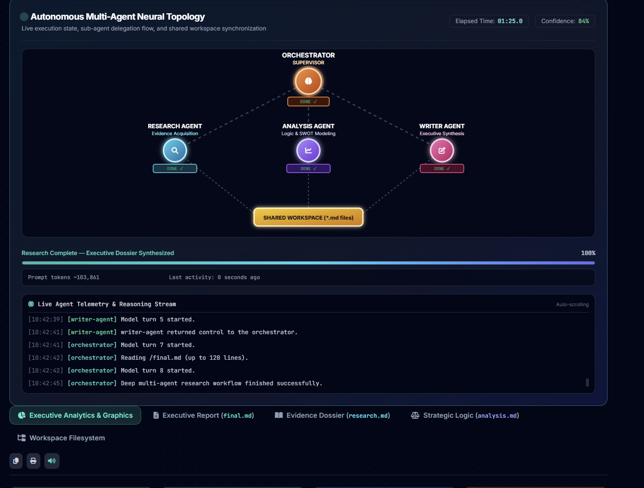

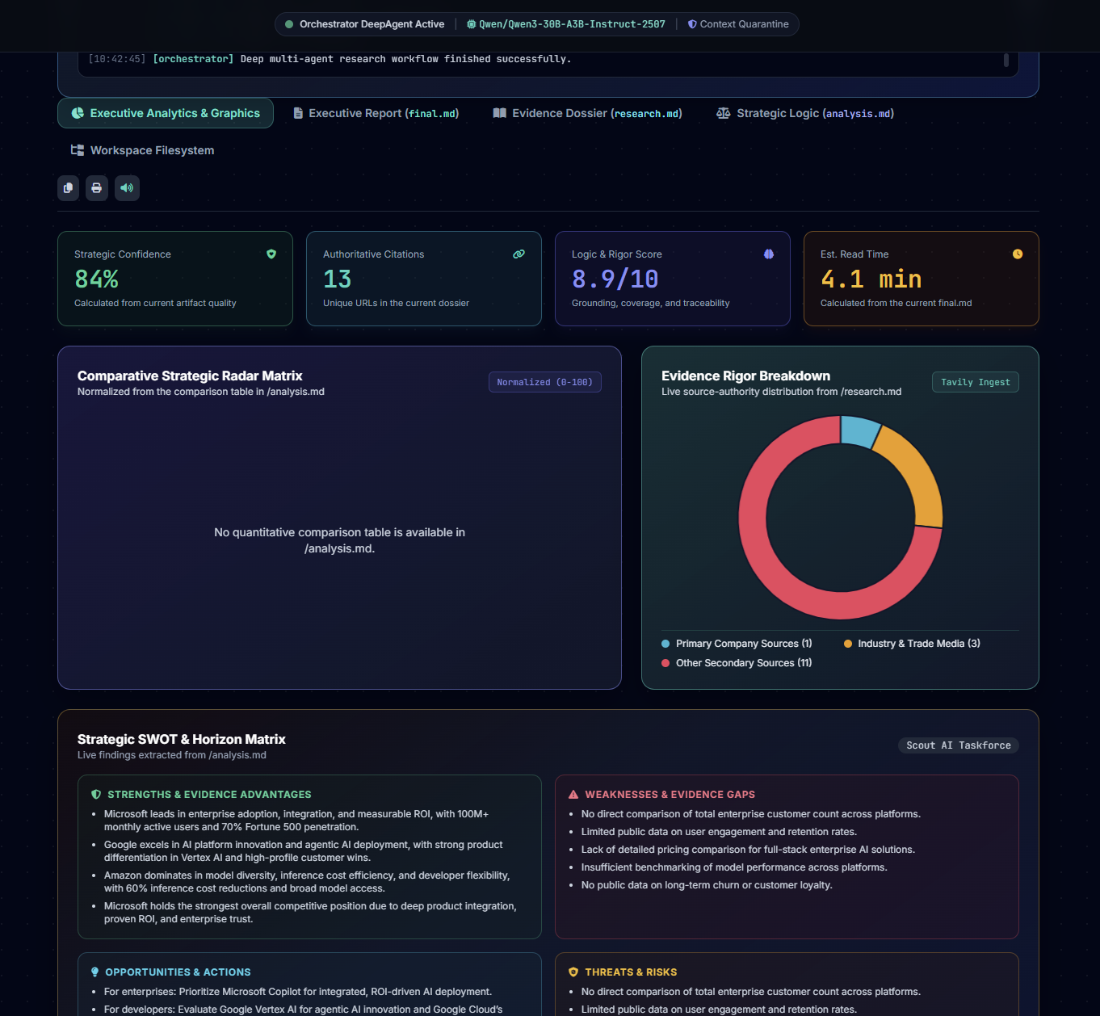

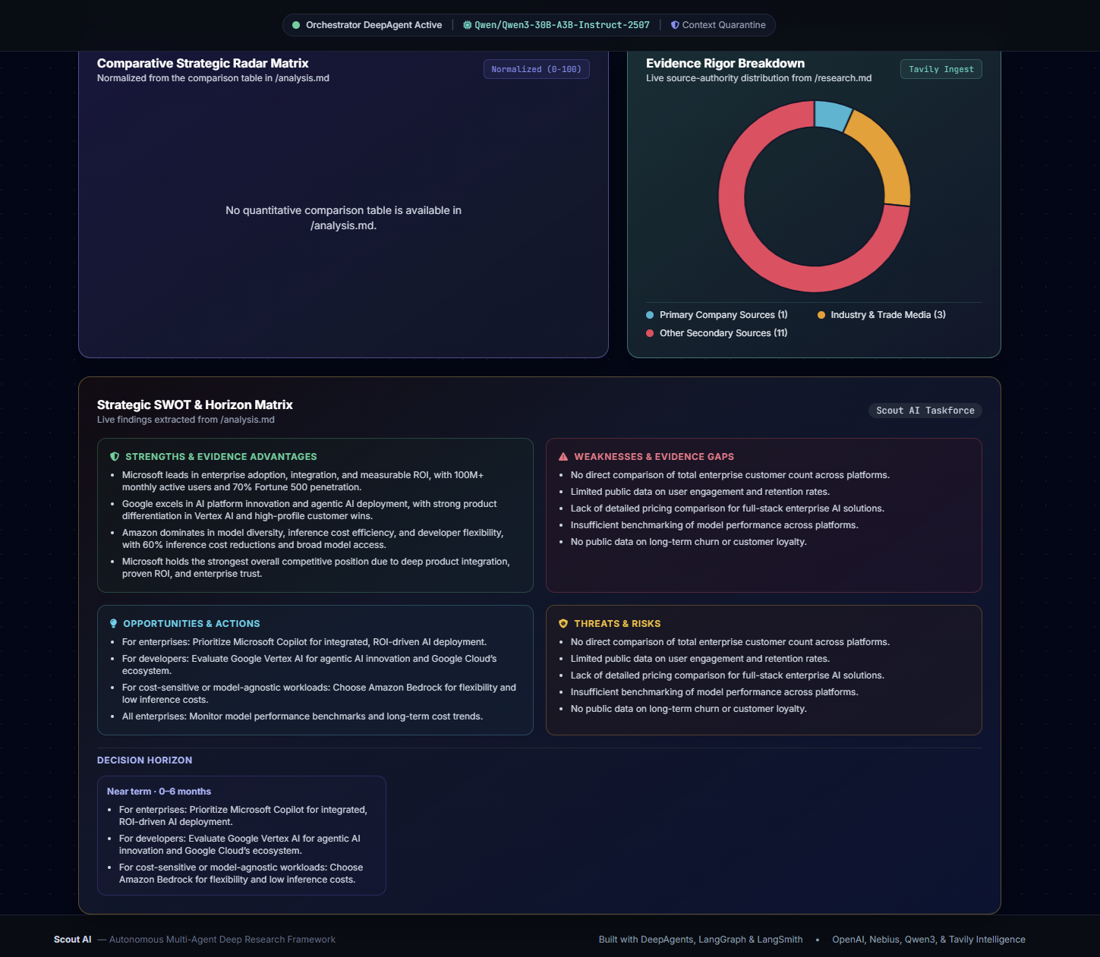

Appendix A - API & Event Contracts

A.1 HTTP Endpoints
Method | Path | Purpose
GET | / | Serve the Scout AI web interface
GET | /api/config | Return provider readiness, model roles, LangSmith status, and model catalog
POST | /api/config | Persist supplied provider/model/LangSmith configuration
POST | /api/research/start | Create a live or simulation task and return task_id
GET | /api/research/stream/{task_id} | Stream current task telemetry and new log entries via SSE
GET | /api/research/history | List dossier summaries in reverse chronological order
GET | /api/research/history/{task_id} | Load a full dossier; recompute live artifact metrics when complete
DELETE | /api/research/history/{task_id} | Delete a stored dossier
POST | /api/export/docx | Generate a Word report with optional research/analysis appendices

A.2 Start Request
{
"query": "string (required, non-empty)",
"depth": "comprehensive",
"focus": "general",
"model": "optional model ID",
"force_simulation": false
}

A.3 SSE Payload Fields
Group | Fields
Identity/status | id, status, progress, mode, error
Activity | active_agent, current_tool, last_activity_at, last_activity_epoch, activity_state
Limits | model_turns, model_turn_limits, graph_recursion_limit, max_attempts, timeout_seconds
Retries | attempts, attempt_started_epochs, backoff_seconds, delegation_counts
Usage | token_usage totals and per-agent breakdown
Quality | sources_count, confidence_score, duration_seconds, router_model, synthesis_model
Incremental output | logs since prior event; current research/analysis/final lengths
Terminal-only | full_files and metrics

Appendix B - Shared Workspace & Prompt Contracts

B.1 Research Ledger
Original research question: <exact question>
Scope/sub-questions: 3-6 bullets
| ID | Claim or metric | Date/scope | Source URL | Source type | Confidence |
| E1 | ... | ... | https://... | Primary/secondary | High/medium/low |
Evidence gaps: <= 5 bullets

B.2 Analysis Artifact
Original research question: <exact question>
Decision summary: <= 5 bullets
Finding matrix: Finding | Evidence IDs | Fact/Inference/Assumption | Decision implication
Compact comparison table
Risks and gaps: <= 5 bullets
Recommended actions: <= 5 bullets
Strategic SWOT & Horizon Matrix with Evidence IDs

B.3 Final Report
- Executive Summary
- Key Empirical Findings & Comparative Breakdown
- Quantitative Metrics & Decision Matrix
- Strategic Recommendations & Action Items
- Verified Sources & Citations

Appendix C - Glossary
Term | Definition
DeepAgents | LangChain-ecosystem framework used to create the supervisor and planning-capable sub-agents.
LangGraph | Graph execution runtime underlying the agent workflow and version-2 event stream.
LangSmith | Tracing and evaluation service for model, tool, chain, and sub-agent runs.
Tavily | Web-search provider used to retrieve current titles, URLs, snippets, dates, and relevance scores.
Router model | Model used by the Orchestrator, Research Agent, and Analysis Agent for planning/tool selection/reasoning.
Synthesis model | Model reserved for Writer Agent final-report generation.
Virtual workspace | DeepAgents state-backed set of exact shared paths used for inter-stage handoff.
Evidence Ledger | Compact research.md table linking each claim/metric to date/scope, source URL, type, and confidence.
Context quarantine | Isolation in which a sub-agent does not see the original conversation and must read /brief.md.
Artifact budget | Maximum line and character size enforced for an inter-stage Markdown file.
Model-call limit | Per-agent ceiling enforced by ModelCallLimitMiddleware.
Graph recursion limit | Maximum LangGraph node transitions allowed for a run; distinct from model calls.
Inactivity timeout | Elapsed silence since the most recent model/tool/token/chain event, not total stage duration.
SSE | Server-Sent Events channel used to deliver live task state from FastAPI to the browser.
Strategic confidence | Deterministic score reflecting artifact quality and traceability; not a probability of truth.
Simulation mode | Explicit unverified workflow preview that performs no live evidence research.

